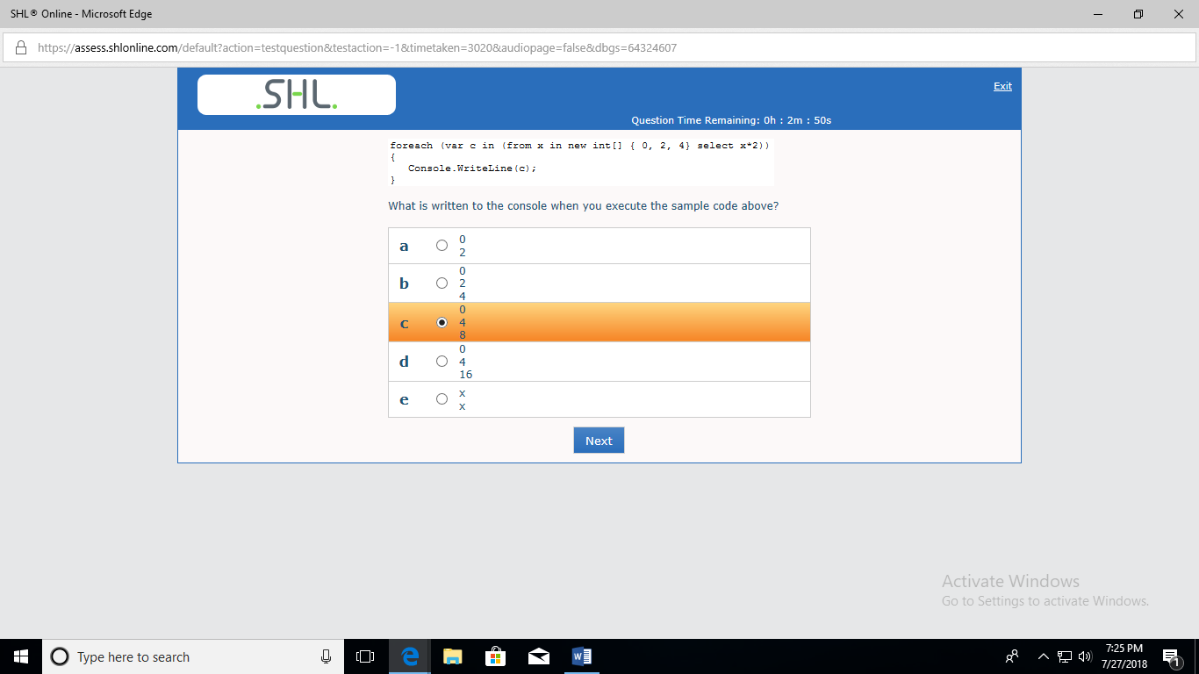

Ans:C

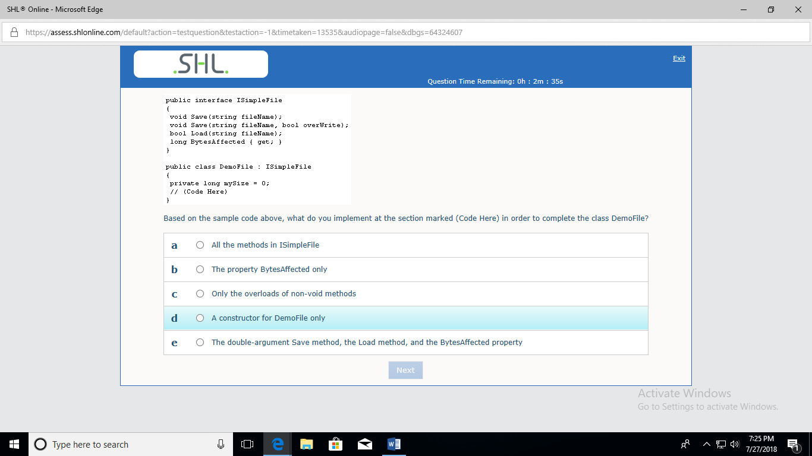

Ans:has to implement all methods and property in interface

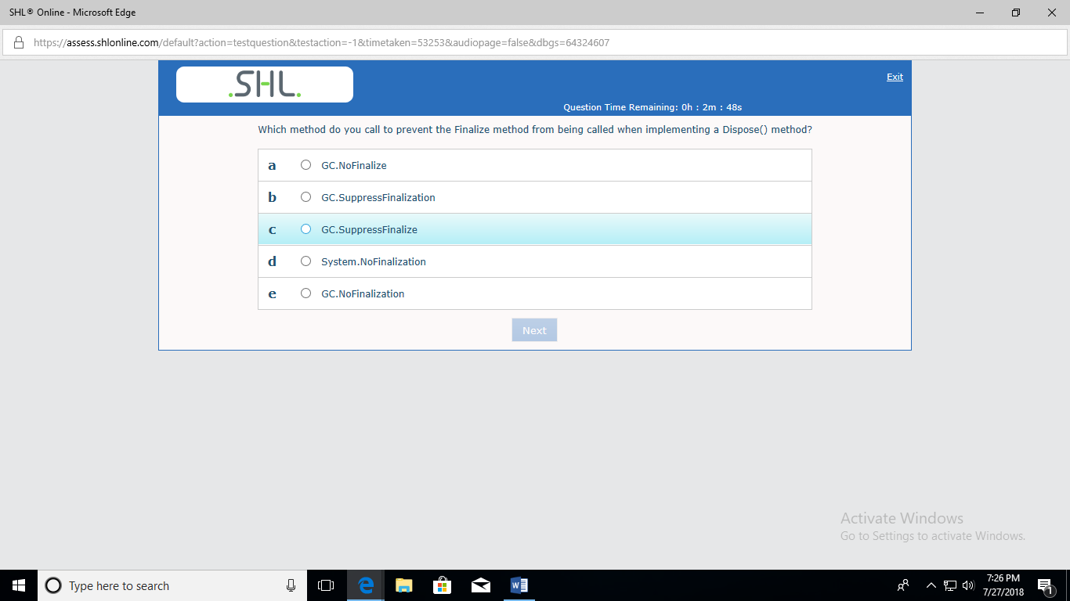

https://www.codeproject.com/Articles/15360/Implementing-IDisposable-and-the-Dispose-Pattern-P

Ans :C

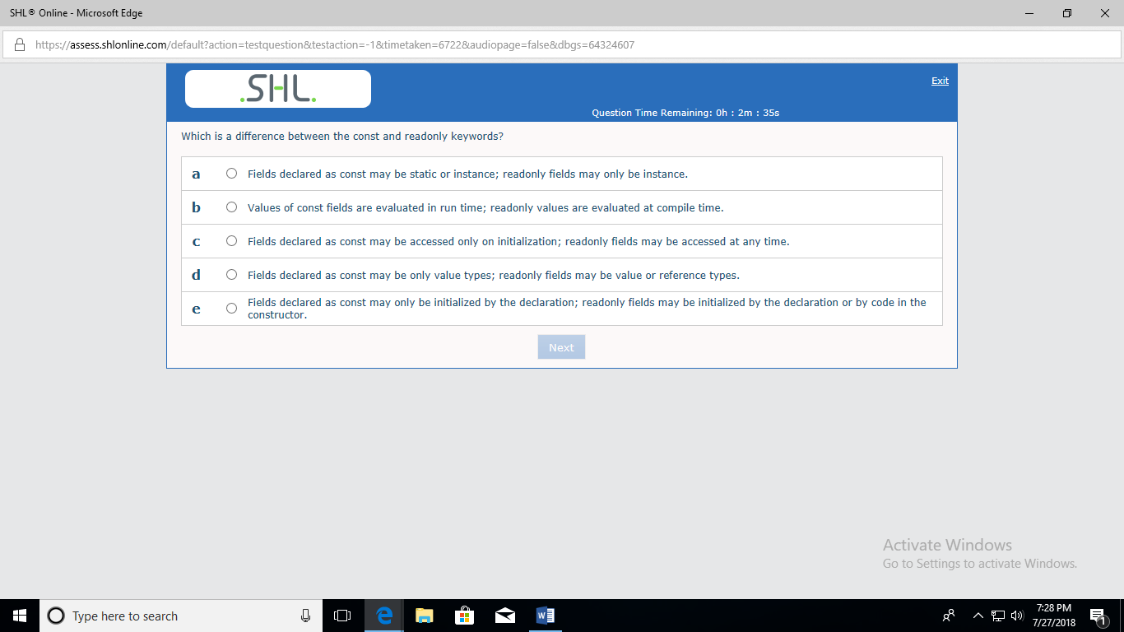

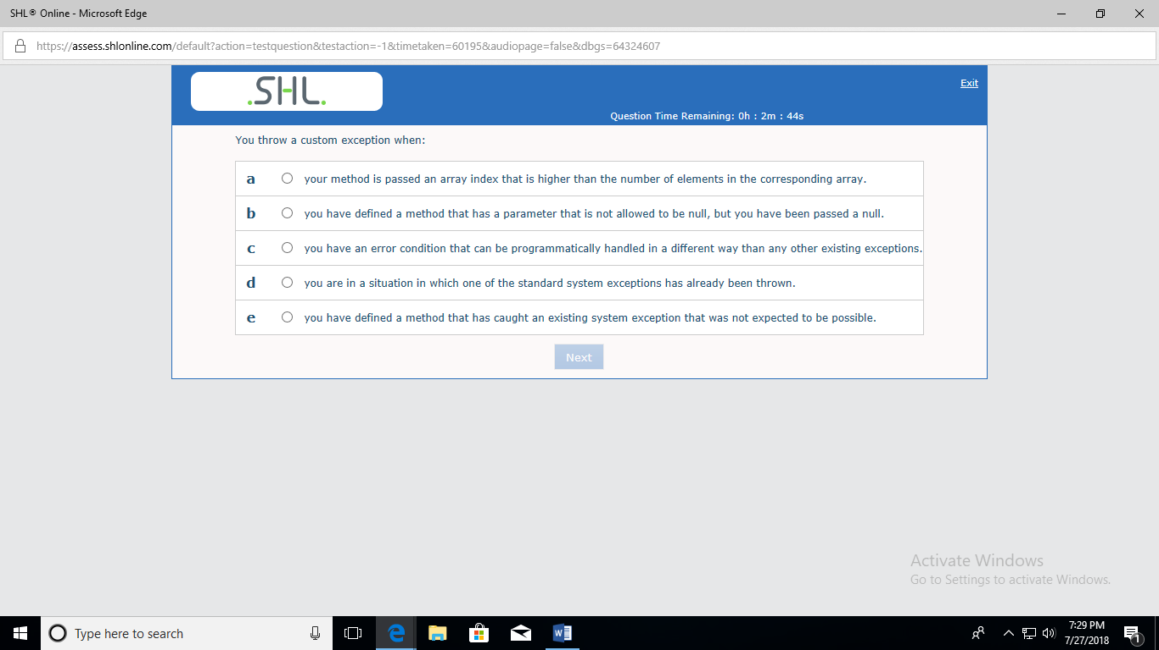

Ans: C

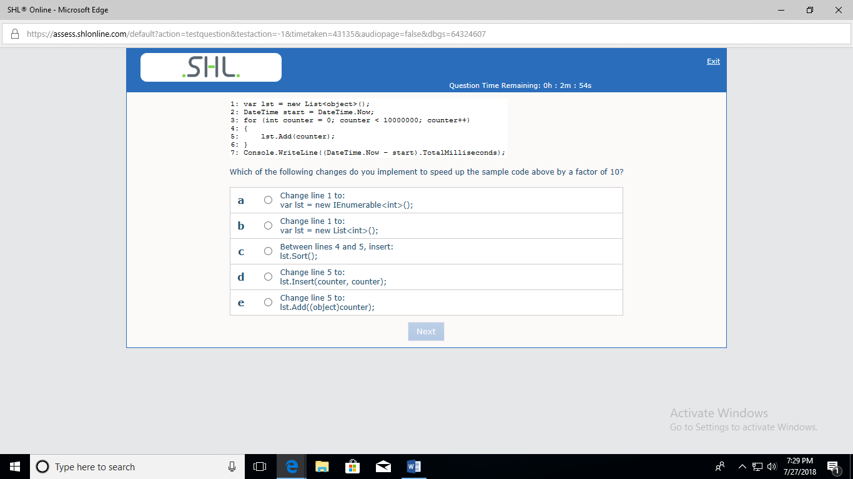

Ans:C

using System;

using System.Collections.Generic;

class Program

{

static void Main()

{

var lst=new List<object>();

// var lst=new IEnumerable<int>();

// var lst=new List<int>(); //158.113

DateTime start=DateTime.Now;

try{

for(int counter=0;counter<10000000;counter++)

{

//lst.Add(counter); //1863.672

//lst.Sort(); //181.181 //269.137

//lst.Insert(counter,counter);//1460.435

//lst.Add((object)counter);//1421.983 //1600.052

}

}

catch(Exception e)

{

Console.WriteLine(e);

}

Console.WriteLine((DateTime.Now-start).TotalMilliseconds);

}

}

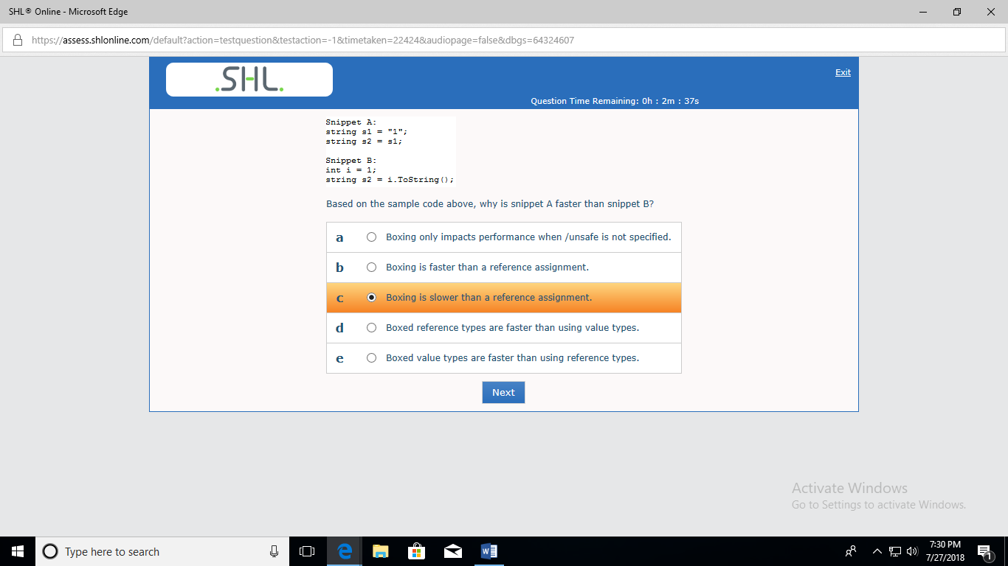

Ans: C

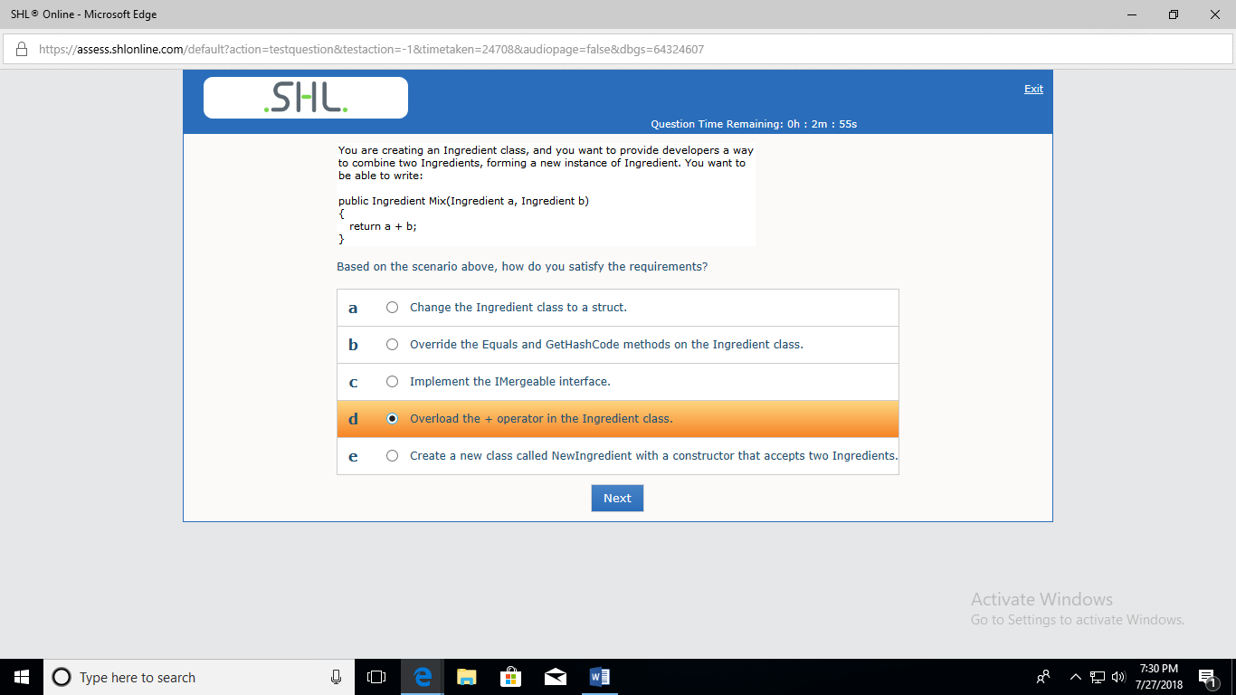

Ans:D

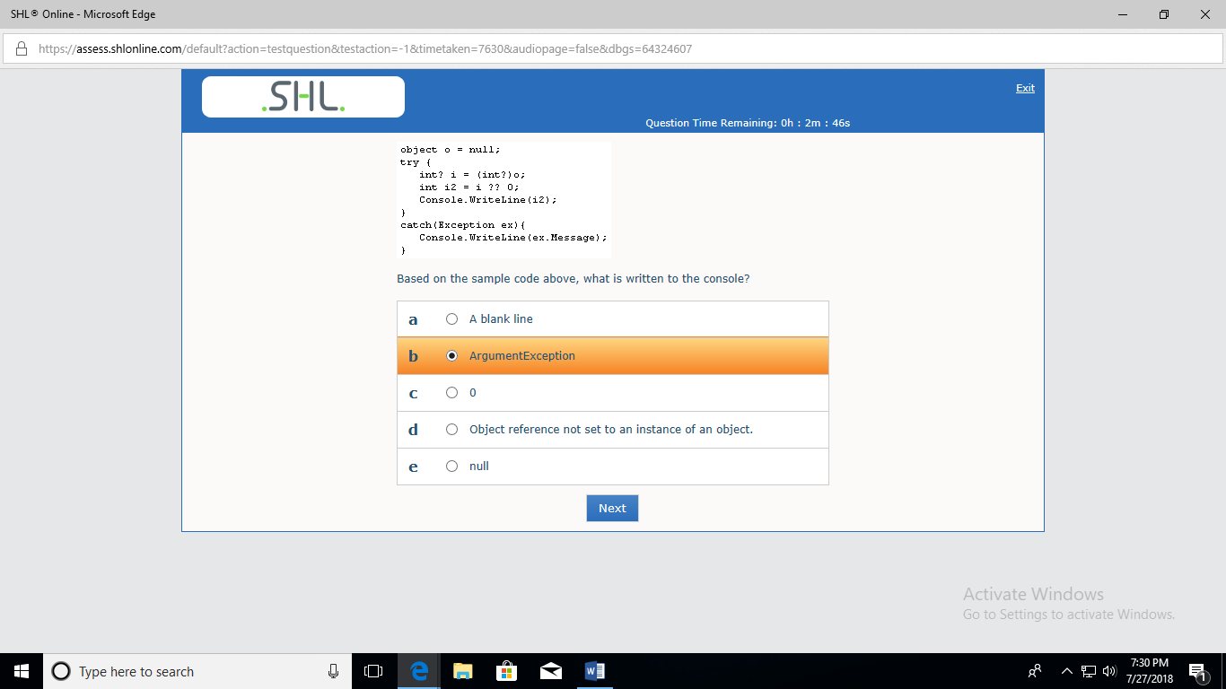

Ans:C

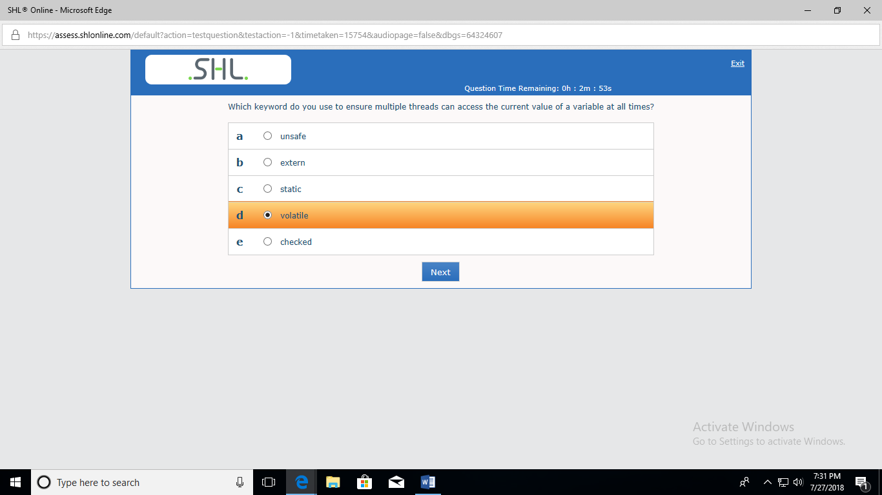

Ans:D

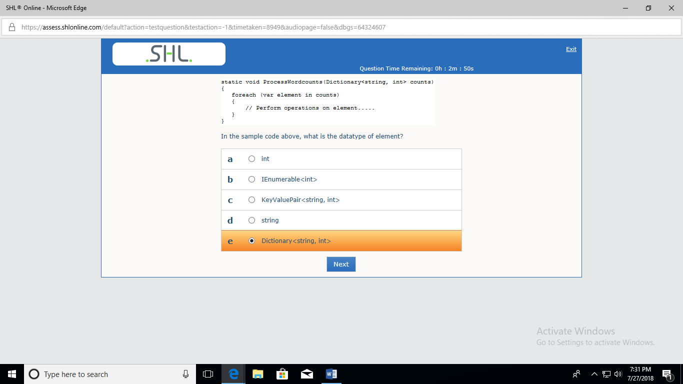

Ans:C

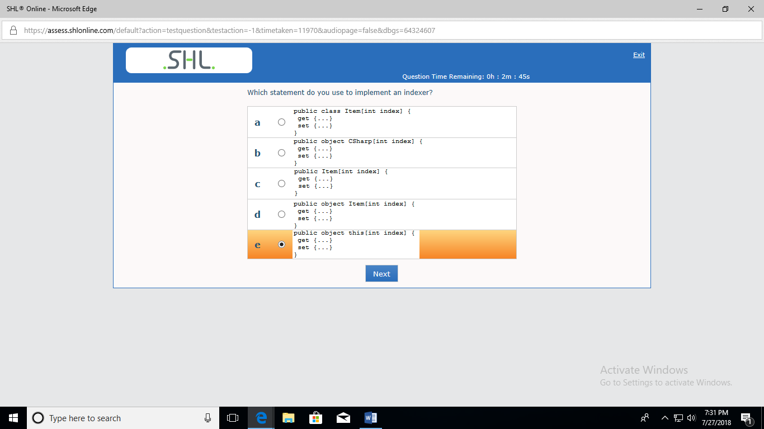

Ans:E

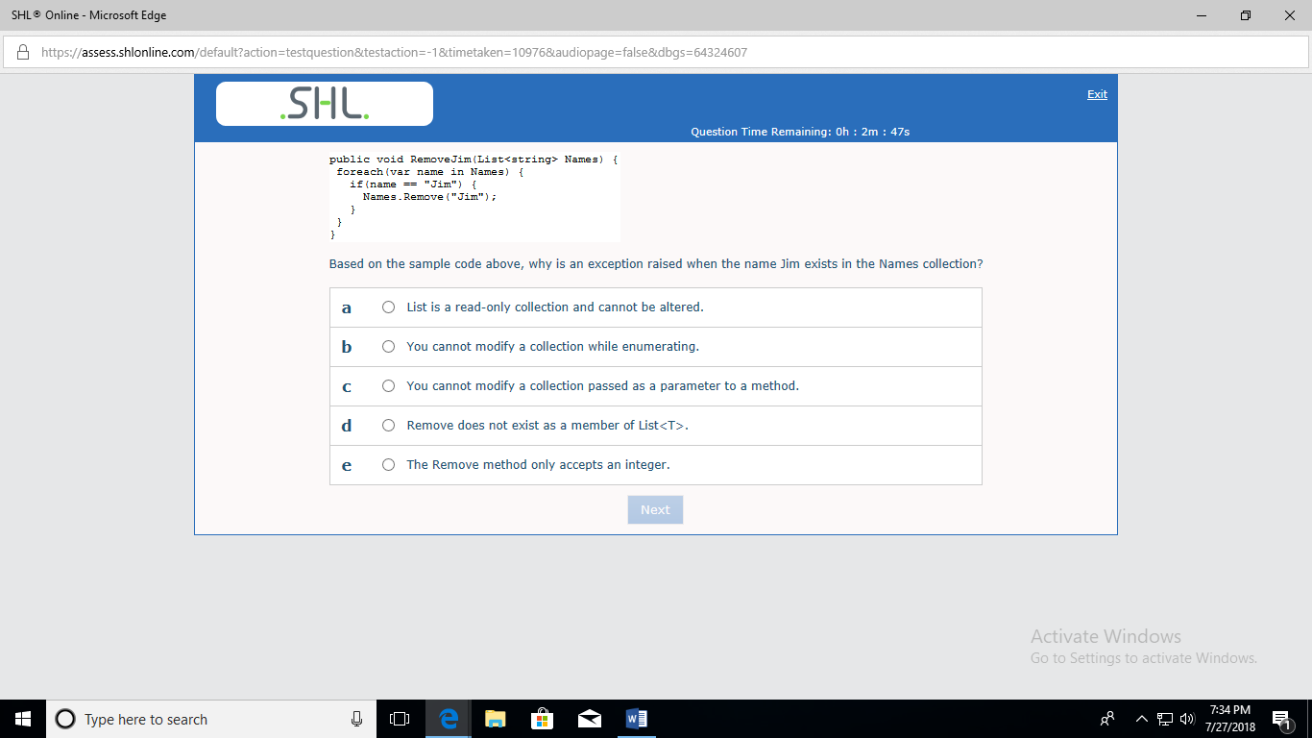

Ans:B